

INFRASTRUCTURE APPLICATION REQUIREMENTS – *APP_Abbr*   
*Full App Name*

* *<optional: clustered applicationname 1>*
* *<optional: clustered applicationname 2>*

Version: x.x

Date: *<day> <month> <year>*

Document purpose

This requirements document (REQ) is used to:

* Gain a common understanding of the application requirements
* Document the requirements relevant for the DXC Infrastructure Application design (IA HLD)

The document outlines:

* External entities
* Functional and non-functional requirements

Relation to other documents

The following documents may be relevant as context to this REQ:

* The Software Architecture Document (SAD)
* The Project Start Architecture (PSA) document
* Infrastructure Application design produced by DXC for related applications (interfaces)

Structure of the document

High level flow: first the application overview and architecture are described followed by the functional and non-functional requirements that ‘drive’ the solution as it will be described in the DXC HLD.

Content of the document

UWV has prepared this document in good faith and is based on the information gathered during the requirement determination phase with all parties involved; application vendors, UWV architects, developers and UWV functional management.

Table of Contents

1 Application Overview 4

1.1 Introduction 4

1.2 Scope of the desired change 4

1.3 Application use cases 4

1.4 Out of Scope 4

2 Architecture 5

2.1 Conceptual 5

2.2 Context diagram 7

3 Non-Functional Requirements 10

3.1 Security & Compliance classifications 10

3.2 System and Software requirements 11

3.3 Performance requirements 14

3.4 Security requirements 14

3.5 Backup and Recovery 15

3.6 Disaster Recovery 15

Appendix A: Template version control 16

Appendix B: Document version control 18

Appendix C: Legenda 19

Legenda Context Diagram 19

Appendix D: MCPaaS – Capacity allocation details 20

# Application Overview

## Introduction

## Scope of the desired change

## Application use cases

*Examples (please remove this text block before or after adding the real values)*

*Example 1*

The following use cases are acknowledged:

* **Fully automatic composition:** The fully automated (STP) composition of standard (batch) communication-exchanges (based on a standard template, personal and generic data, and visual elements) with the option to assess and approve the final result.
* **Semi-automatic composition:** The semi-automated composition of standard communication-exchanges (based on a standard template, personal and generic data) with the option to adjust, assess and approve the concept result.
* **Fully manual composition:** The fully manual composition of standard communication-exchanges (based on a standard template, personal and generic data, visual elements and manual textblocks) with the option to assess and approve the final result.

*Example 2*

Use case: UWV end user requires direct access to data (database) outside the application as part of a person’s job position

## Out of Scope

*Examples (please remove this text block before or after adding the real values)*

* All components that belong to the UWV Office Infrastructure such as workstations, web browsers are out of scope.
* O and T are not part of this requirements document as they are supplied by the Totem team
* Software installation on UCRA is out of scope

# Architecture

## Conceptual

*Examples (please remove this text block before or after adding the real values)*

The conceptual diagram looks like this:

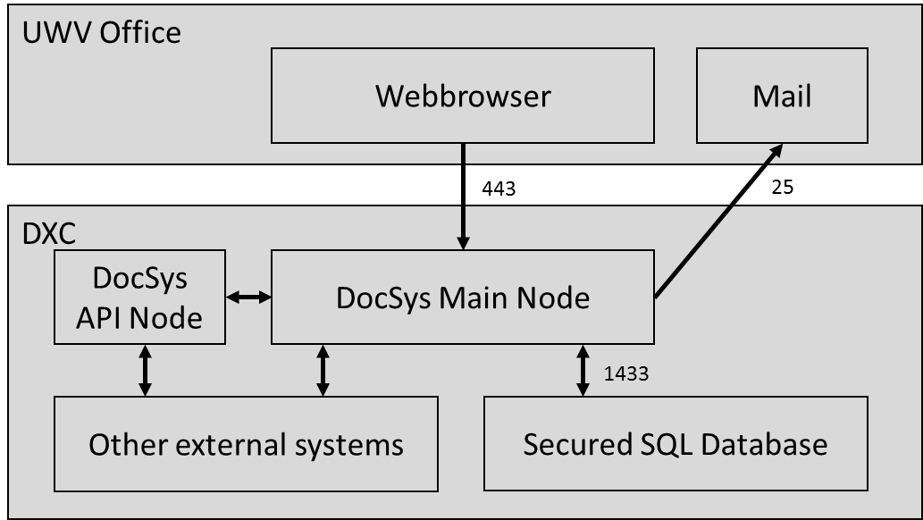

* + DocSys Flow Online (Workflow Management)
  + DocSys API Management (Interfaces)
  + DocSys Textblock Index Service (Dependency Viewer)
  + FDDG (Backend document processing)
  + Engine (Message generation)
* **Application installation:** Two types of nodes are employed: the DocSys Main Node containing the DocSys Platform (including all of its aforementioned components); one specific DocSys API Node (containing exclusively DocSys API Management), which is primarily utilized for STP bulk transactions. This means that DocSys API Management is installed on both types of nodes.
* **Application integration:** The DocSys Platform configures its connections with other external application through its DocSys API Management component. MQ and HTTP (SIP-AMG) are employed for these connections.
* **Type of infrastructure:** The DocSys Platform is installed on-premise on a virtualised infrastructure in a cluster setup.
* **OTAP setup:**
  + **Test Domain (Product T):** Initial deployment of the application and test of connections and application configuration. No load balancing and no HA configuration available.
  + **Acceptance Domain:** Acceptance of application (configuration) changes **(Product A)** and E2E testing **(Product K)**. Load balancing and HA configuration available for the DocSys Main Node (and not the DocSys API Node).
  + **Production Domain (Product P):** Four separate environments are arranged **(Content OTAP)**, with each a dedicated hosting service. Load balancing and HA configuration available for the DocSys Main Node (and not the DocSys API Node).
* **Application Architecture:** The DocSys Platform consists of the following application components and are installed on the DXC infrastructure:
  + DocSys Online (UI)

*Example* *(please remove before adding the real values)*

|  |  |  |  |  |  |  |  |
| --- | --- | --- | --- | --- | --- | --- | --- |
| **UWV Domain** | **Name** | **Environment** | **Goal** | **High-Available** | **Load balancing** | **Integration** | **Accessible for** |
| TEST | TEST | Product T | Initial deployment of the application and test of connections and application configuration. | No | No | Stubs | Administrator  System tester  System developer |
| ACC | ACC | Product A | Acceptance of application (configuration) changes by DocSys Administrators. | Yes | Yes | All interfaces | Administrator  System tester |
| KET | Product K | E2E Test environment for parties that integrate with DocSys. | Yes | Yes | All interfaces | Administrator  Systeem tester  Chain partners |
| PROD | PROD | Product P, consists of: | Environment in which the end-user (including content management and administratos) carries out daily work. | Yes | Yes | All interfaces | Administrators |
| - PROD1 | - Content O | **Content Editor:** Workplace for content administrators, for creating textblocks, etc. | Yes | Yes | Stubs | Content Management |
| - PROD2 | - Content T | **Content Review:** Workplace for reviewing documents by teams and editors. | Yes | Yes | Stubs | T.b.d. |
| - PROD3 | - Content A | **Content Final review:** Acceptance of content by those responsible. | Yes | Yes | All interfaces, except MOM and mail | Users from department |
| - PROD4 | - Content P | **Content Publication:** Content that end-users see during creation of communication-exchanges. | Yes | Yes | All interfaces | End-users |

* **Transactions:** Online transactions and batch transactions occur in separate environments. These environments will be arranged after the first-user implementation.
* **Webbrowser:** UWV users access the DocSys Frontend (DocSys Online) through a standard webbrowser (Microsoft Edge) over HTTPS (port 443).
* **Mail:** UWV users can be notified by DocSys by e-mail. For this, DocSys accesses the UWV Mail server over SMTP (port 25).
* **Webserver:** The DocSys Main Node utilizes at the very least .NET Framework 4.7.2 and .NET 6.0 in Windows Server 2019 IIS on a VMWare Virtual Machine. DocSys API Node utilizes only at the very least .NET 6.0 in Windows Server 2019 IIS on a VMWare Virtual Machine.
* **Datavault:** A SQL datavault (Microsoft SQL Server 2019) is made available for access to sensitive business data (port 1433).
* **Authentication:** UWV users access DocSys through Single Sign-On (OpenIDConnect through ADFS). The authorization is divided into two parts:
  + The authorization at the level of users and their functions/roles from which they derive rights. This form of authorization is technically regulated in ABS and AD.
  + The authorization at the level of rights within an application. DocSys Online retrieves AD user groups and relates them to DocSys user groups. These DocSys user groups describe which users have access to which (content) elements and actions in the front-end and thus to transactions in the back-end.

## Context diagram

< Context diagram is applicable for Private Cloud sytems, Container Applications and Hybrid situations, the green circle represents the application (and does not specify where it is hosted). In all cases it is important to understand the external connections for the application >

*Examples (please remove this text block before or after adding the real values)*

Example 1

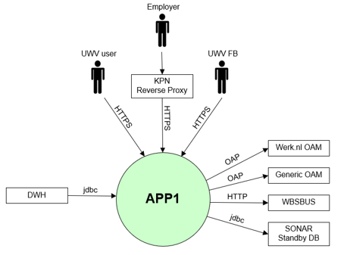

### External entities

#### Entity 1-n

|  |  |
| --- | --- |
| **Description** | <Short description (mandatory)> |
| **Protocol and Port** | <Specify protocol and port (mandatory field)> |
| **DC (Datacenter) connection** | Select (mandatory field) |
| **Direction** | Select (mandatory field) |
| **Direct connection** | Select (mandatory field)  Via: <If No is selected specifiy otherwise mention not applicable> |
| **Security Controls** | Authorisation method or authentication method: Select (mandatory)  Use certificates: Select (mandatory)  Service account: Select (mandatory)  Other: <(only mention if applicable) other applicable security control related configuration> |
| **Number of users** | <Preferred if known otherwise “not specified”> |
| **Number of transactions** | <Preferred if known otherwise “not specified”> |
| **Frequency of transactions** | <Preferred if known otherwise “not specified”> |
| **Volume of data in transit** | <Preferred if known otherwise “not specified”> |

#### Entity n

|  |  |
| --- | --- |
| **Description** | <Short description (mandatory)> |
| **Protocol and Port** | <Specify protocol and port (mandatory field)> |
| **DC (Datacenter) connection** | Select (mandatory field) |
| **Direction** | Select (mandatory field) |
| **Direct connection** | Select (mandatory field)  Via: <If No is selected specifiy otherwise mention not applicable> |
| **Security Controls** | Authorisation method or authentication method: Select (mandatory)  Use certificates: Select (mandatory)  Service account: Select (mandatory)  Other: <(only mention if applicable) other applicable security control related configuration> |
| **Number of users** | <Preferred if known otherwise “not specified”> |
| **Number of transactions** | <Preferred if known otherwise “not specified”> |
| **Frequency of transactions** | <Preferred if known otherwise “not specified”> |
| **Volume of data in transit** | <Preferred if known otherwise “not specified”> |

*Examples (please remove this text block before or after adding the real values)*

|  |  |
| --- | --- |
| **Description** | Employer who is accessing the application from the internet |
| **Protocol and Port** | HTTPS (443) |
| **DC (Datacenter) connection** | External |
| **Direction** | Inbound |
| **Direct connection** | No  Via: KPN Reverse Proxy |
| **Security Controls** | Authorisation method or authentication method: OAM  Use certificates: Yes (Entrust)  Service account: No |
| **Number of users** | 100 concurrent |
| **Number of transactions** | not specified |
| **Frequency of transactions** | not specified |
| **Volume of data in transit** | not specified |

# Functional Requirements

# Non-Functional Requirements

## Security & Compliance classifications

Repository used is: “2022 UWV-brede Risico Applicatie Lijst v1.0”

The BIV rating (confidentiality) will result in chosing the UWV data appropriate zoning principals.

|  |  |
| --- | --- |
| **Application** | <application name> |
| **Owner** | <division name> |
| **Availability (Beschikbaarheid)** | Select |
| **Integrity (Integriteit)** | Select |
| **Confidentiality (Vertrouwelijkheid)** | Select |
| **Type of information /Data Classification** | <specify> |

### Risk analysis UWV

*Examples (please remove this text block before or after adding the real values)*

Example 1

UWV has composed a GEB report, which includes a risk analysis. These privacy and security related risks are mitigated in the arrangement of E-Publication.

Example 2

During product selection a UWV risk analysis has been conducted

### Applicable security and compliance frameworks

|  |  |  |
| --- | --- | --- |
| Security & Compliance Framework | Applicable | Comments |
| BIO | Select | If Applicable=No please explain |
| AVG / GDPR | Select | Only select No if no personal data is handled. GPDR is mandatory in all other cases |
| DIGID | Select |  |
| SUWI | Select |  |
| Additional frameworks | Specify any additional security or compliance framework |  |

## System and Software requirements

### Private Cloud system

#### System (Operating system (OS))

| **Server(type)** | **Operating System** | **Version** |
| --- | --- | --- |
| <example: Database server 1> | <RHEL> | <8.5> |
|  |  |  |

#### System capacity forecast (volumetrics)

| **Server(type)** | **vCPU** | **RAM (GB)** | **Data Storage (GB)** |
| --- | --- | --- | --- |
| <example: Database server 1> | 2 | 8 | 500 |
|  |  |  |  |

#### Availability

|  |  |  |
| --- | --- | --- |
| **Environment** | **Application Target**  (Availability (service hours) = SLA) | **Infra Target* (only for Application target 98%)**  (Availability (service hours) = SLA) |
| Production | 99,8% (7x24) = TAB Extra | 99,8% (7x24) = Gold |
| Acceptance | 99,5% (7x24) = TAB Plus | 99,8% (7x24) = Gold |
| Test | 98% (5 x12 (Mo-Fr, 7-19h)) = TAB Basis | 98% (7x24) = Bronze |
| Select | Select | Select |

*Aplication Target TAB Plus and TAB Extra always require Infra Target Gold

#### Storage replication

|  |  |
| --- | --- |
| **Environment** | **Storage Replication** |
| Select | Select |
| Select | Select |

#### Scalability

| **Server(type)** | **Scalability type** | **Additional Comments** |
| --- | --- | --- |
| <example: Application server 1> | Horizontal | Load balanced |
| <example: Application server 1> | Vertical | Additional CPU |

Load balancing type: < application or infra - based>

Load balancer infra requirements (when applicable):

|  |  |
| --- | --- |
| **Application Layer** | HTTP (L7) |
| **Application Port(s)** | 80 |
| **Algorithm** | Least Connections (default) |
| **Stickiness/Persistence** | None |
| **Health monitor type** | System-HTTP |

Known application scalabilty limitations: <provide when applicable otherwise state n/a >

#### Software (Licenses)

| **Server(type)** | **Software product / component** | **Version** |
| --- | --- | --- |
| <example:Database server 1> | <Oracle Database server> | <19c> |
| <example:Database server 1> | <Oracle Active Data Guard> | <19c> |

#### System management

< specify or state No system management requirements are applicable.>

**Additional application related infra requirements**

|  |  |
| --- | --- |
| **Requirements** | **Status** |
| Use STARTTLS option for UWV mail | Select |
| Is Microsoft DTC used for inflight transactions | Select |
| Is HTTPS cookie stickiness required on the load balancer | Select |
| Mention other relevant requirements |  |

#### DXC TAB requirements

|  |  |
| --- | --- |
| **Category** | **Description** |
| Deployment method | XL deploy)/ Azure DevOPS / Application specific deployment method / Manual deployment> |
| Deployment permissions |  |
| Application Monitoring |  |
| Application Logging |  |
| Other TAB applicable requirement |  |

### Container application (MCPaaS)

#### Capacity allocation

| **MCPaaS Namespace** | **Domain** | **CPU**  **Initial** | **CPU**  **limit** | **Memory (GB)**  **Limit** | **Memory (GB)**  **Limit** | **Storage**  **(GB)** | **User Groups** |
| --- | --- | --- | --- | --- | --- | --- | --- |
| <example: CompetentNL-O> | Development | 1 | 4 | 32 | 64 | 150 |  |
| <example: CompetentNL-T> | Test | 1 | 4 | 32 | 64 | 150 |  |
|  | Acceptance |  |  |  |  |  |  |
|  | Production |  |  |  |  |  |  |

Remark: Capacity details for each pod is documented in Appendix D (Pods are the rough equivalent of a machine instance (physical or virtual) to a container. Each pod is allocated its own internal IP address)

#### Availability

|  |  |  |
| --- | --- | --- |
| **Environment** | **Application Target**  (Availability (service hours) = SLA) | **Infra Target* (Same as MCPaaS availability)**  (Availability (service hours) = SLA) |
| Production | AppOps | 99,8% (7x24) = Gold |
| Acceptance | AppOps | 99,8% (7x24) = Gold |
| Test | AppOps | 98% (7x24) = Bronze |
| Development | AppOps | 98% (7x24) = Bronze |

*Infra target is the same as for the container platform, therefore no choice the values here are information

#### Software (Licenses)

| **Container or Application** | **Software product / component** | **Version** |
| --- | --- | --- |
| <example: PES suite> | < example: PES bemiddelingsservice (8vance) > |  |

#### System management

< specify or state No system management requirements are applicable.>

**Additional application related infra requirements**

|  |  |
| --- | --- |
| **Requirements** | **Status** |
| Use STARTTLS option for UWV mail | Select |
| Can the standard Azure container registry be used by the MCPaaS application | Select |
| Mention other relevant requirements |  |

#### DXC TAB requirements

|  |  |
| --- | --- |
| **Category** | **Description** |
| Deployment method | Azure DevOPS |
| Application Monitoring |  |
| Application Logging |  |
| Other TAB applicable requirement |  |

## Performance requirements

*Examples (please remove this text block before or after adding the real values)*

The total size for Production is approximately 40 GB. 16 GB of RAM should be allocated. Finally, a processor is required with x86-64 architecture and access to two or more (4 cores are required for 1 node to handle the full load) processors. The DocSys application will be used by a maximum of 5000 concurrent users.

The following additional non-functional requirements have been specified for this application environment with regards to the performance of the infrastructure.

* The end-to-end performance (total transaction time – 99th percentile) of DocSys interfaces:
  + UHR: 100 ms
  + WGA: 100 ms
  + UPA: 100 ms
  + EA: 200 ms

## Security requirements

*Examples (please remove this text block before or after adding the real values)*

• Authentication and Authorization: Users accessing DocSys (through the webbrowser) authenticates themselves with their UWV account. This authentication is provided by Active Directory Federation Services (ADFS).

• Elevated permissions: Read /write permissons on the database

• The application owner would like to have multi-factor authentication, or 4-eyes principles

### System logging retention time

## Backup and Recovery

|  |  |  |
| --- | --- | --- |
|  | **Default** | **Deviation (when applicable)** |
| Backup | standard backup | Specify deviation (see instruction for backup standards) |
| Restore | no specific restore order | Specify restore order when applicable |
| Dependency | no dependencies | Specify dependency when applicable ( for example backup with the same time stamp is required to avoid data inconsistency) |

## Disaster Recovery

No specific disaster recovery requirements applicable.

# Appendix A: Template version control

**TEMPLATE CHANGE HISTORY**

|  |  |  |
| --- | --- | --- |
| Version | Date | Summary of Changes |
| 0.1 | 08-07-2022 | * Initial version UWV requirements template, ready for review |
| 0.2 | 13-07-2022 | * Included review comments Giuliana to prepare for follow-up meeting |
| 0.3 | 14-07-2022 | * Included review comments Giuliana and Henk-Jan to prepare for REQ template pilot |
| 0.8 | 14-07-2022 | * Cora marked the REQ template v0.8.  Prepared for final UWV review and the additional writer’s instruction from Thomas H, Remco H and Walter |
| 0.9 | 25-07-2022 | * Pre-pilot version |
| 0.91 | 27-07-2022 | * Split Appendix A in A and B for document control |
| 0.92 | 11-08-2022 | * improved instructions after 1st workshop with IO&R hosting team and evaluation of pilot (use case: edit HLD for existing application) |
| 0.93 | 24-08-2022 | * improved instructions after 2nd workshop with IO&R hosting team |
| 0.99 | 28-10-2022 | * Improved and added instructions by Henk-Jan after evaluation of first use in production and to finalize template to v1.0 |
| 1.0 | 11-01-2022 | Finalized with the following adjustments   * Updated 4.4 includes service level and service hours * Updated 4.8 Added note for AIX Bronze systems |
| 1.1 | 02-01-2023 | * Updated instructions for certificate selection |
| 1.2 | 23-02-2023 | Updated the template with MCPaaS (Managed Container Platform as a Service) specific requirements   * Removed Chapter 3 (functional requirements), Evaluation shows that this is either not filled or when it is filled the requirements are non-funtional. Functional requirements for the application are documented in the application design (SAD) * Moved chapter 4.8 (storage replication) under 3.2.1 to bundle the Private Cloud (build)requirements together * Moved chapter 4.4 (Availibility), 4.6 (System management) and 4.10 (TAB requirements) under 3.2.1 and 3.2.2 to bundle the Private Cloud system and Container application requirements together * Moved chapter under 3.2.1 and 3.2.2 to bundle the Private Cloud system and Container application requirements together * Updated 4.2 System and Software requirements: seperate section for Private Cloud and MCPaaS * Updated 4.4 Availability: seperate section for Private Cloud and MCPaaS * 4.6.1 – added addition MCPaaS related infra requirement: Can the standard azure container registry be used by the MCPaaS application |
| 1.21 |  | Added Chapter 3 again: Functional requirements, to keep all chapter the same also for old documentation and to have the possibility to document functional requirements that might seem relevant  Updated 4.2.1.5 System management   * Added load balancer requirements * Added known application scalability limitations |

# Appendix B: Document version control

**USED TEMPLATE**

|  |
| --- |
| Based on REQ Template: UWV REQ – TEMPLATE 1.2.docx |

**CHANGE HISTORY**

|  |  |  |  |
| --- | --- | --- | --- |
| Version | Date | Author | Summary of Changes |
|  |  |  |  |
|  |  |  |  |
|  |  |  |  |
|  |  |  |  |
|  |  |  |  |
|  |  |  |  |

# Appendix C: Legenda

## Legenda Context Diagram

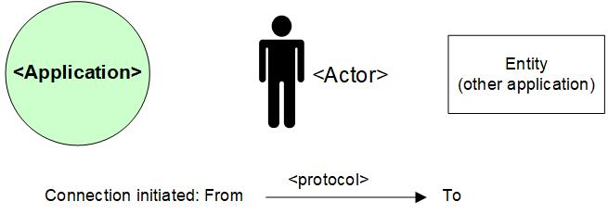

# Appendix D: MCPaaS – Capacity allocation details

**EXAMPLE**

**Capacity allocation for <CompetentNL>**

To manage the resource allocation and assure the project uses only appropriate or agreed resources on the cluster, the quotas and limits to compute resources for the CompetentNL projects on the MCPaaS will be based on below details.

|  |  |  |  |  |  |  |
| --- | --- | --- | --- | --- | --- | --- |
| **Service (pod)** | **Mem Reservation** | **Mem Limit** | **CPU Reservation** | **CPU Limit** | **Scale - nr of containers (Development)** | **Scale - nr of containers (Test)** |
| CNL-Backend | 256M | 512M | 0,1 | 0,3 | 1 | 1 |
| CNL-Frontend | 128M | 256M | 0,1 | 0,5 | 1 | 1 |
| CNL-IAM | 256M | 512M | 0,1 | 0.5 | 1 | 1 |
| CNL-Dataloader | 256M | 512M | 0,1 | 0,2 | 1 | 1 |
| CNL ActiveMQ | 256M | 512M | 0,1 | 0,3 | 1 | 1 |
| CNL-Config-server | 128M | 256M | 0,1 | 0,2 | 1 | 1 |
| CNL-api | 256M | 512M | 0,1 | 0,5 | 1 | 1 |
| CNL-Synchronization | 128M | 256M | 0,1 | 0,3 | 1 | 1 |
| CNL-DB Management | 128M | 256M | 0,1 | 0,2 | 1 | 1 |
| CNL-Search | 1024M | 3072M | 0,1 | 1 | 1 | 1 |

*Total Required resource allocation*

*Note: Required resource allocation for Development and Test is an initial estimation. After initial tests on these environments resource allocation for all environments will be finalized and updated. Besides the resource allocation for Acceptance and Production are based on the experiences from Development and Test.*

|  |  |  |  |  |
| --- | --- | --- | --- | --- |
| **Size description** | **Development** | **Test** | **Acceptance** | **Production** |
| Mem minimum run | 2816M | 2816M | TBD | |
| Mem maximum run | 6656M | 6656M |
| CPU reservations | 1 | 1 |
| CPU reservations limit | 4 | 4 |